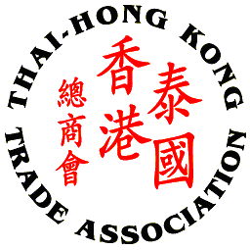
Thai - Hong Kong Trade Association

THTA CHINESE NEW YEAR CELEBRATION 2015

PRIZE DONOR REPLY FORM

Please complete this form and return to THTA Office via E-mail: thai-hongkong@thta.or.th or Fax: 02 343 9029 by Monday, 2nd March 2015

Company Name: ___________________________________________________
Company Address: _________________________________________________________
_________________________________________________________________________
Contact Person: ___________________________ Position: ________________________
Tel No.: _________________ Fax No.: _________________ E-mail: _________________

I/We would like to sponsor the following items for the lucky draw:

Description: (Details of prizes including Quantity and Worth)
_________________________________________________________________________

_________________________________________________________________________

_________________________________________________________________________
- Company name/logo prominently displayed on the e-invitation and Backdrop
- Company name/logo on all correspondence and Thank you email.
- Recognition of contribution on website, with logo display.
***For your kind sponsorship, please attached your high resolution company logo file to displayed on the event***

Signature: ____________________

( )
Date: ________________________

